Safeguarding in our Parish
Our Parish Safeguarding Officer is

Diocesan Safeguarding Team

safeguarding@cofeguildford.org.uk, Tel. 01483 790379

Normal working hours: Monday – Friday 9am-5pm

Safe Spaces, an independent service supporting survivors of church-related abuse. Telephone: 0300 303 1056 (answerphone available outside of opening times) Email safespaces@victimsupport.org.uk WebChat via the Safe Spaces website

For all emergencies call 999

The Multi-Agency Safeguarding Hub (MASH)
Children’s Service social workers, Adult’s Service social workers, health and police staff.
West Sussex 01403 229 900 (office hours)
0300 222 6664 (out of hours) MASH@westsussex.gcsx.gov.uk

Domestic Abuse
West Sussex 07834 968539 or 0330 222 8181
24hr National Domestic Abuse Helpline 0808 2000 247
DeafHope (BSL) text: 07970 350366
Childline 0800 1111

National Society for the Prevention of Cruelty to Children
NSPCC 0808 800 5000 or help@nspcc.org.uk
NSPCC Sign Video link nspcc.org.uk/about-us/contact-us

Samaritans 116123 or jo@samaritans.org
Modern Day Slavery Helpline 0800 0121700
Mental Health Crisis Helpline 0300 5000 101
Available 24 hours, seven days a week in West Sussex

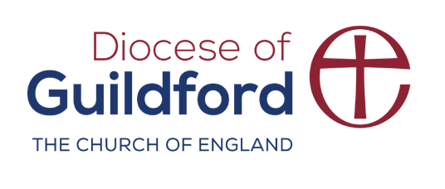
Stop it Now! 0808 1000 900 www.stopitnow.org.uk

cofeguildford.org.uk/safeguarding

